T MINI PROJECT REPORT

ON

TRAFFIC SIGNAL CONTROL SYSTEM

BACHELOR OF TECHNOLOGY

In

ELECTRICAL AND ELECTRONICS ENGINEERING

By

S.PRIYANKA 20NN1A0225

Y.SWATHI KIRAN 20NN1A0226

TRISTHI 20NN1A0227

M.LEELA LAKSHMI 20NN1A0228

MOUNIKA 20NN1A0229

UNDER THE ESTEEMED GUIDANCE OF

Dr.S.L.SHIRISHA

HEAD OF THE DEPARTMENT



DEPARTMENT OF ELECTRICAL AND ELECTRONICS ENGINEERING

VIGNAN’S NIRULA INSTITUTE OF TECHNOLOGY AND SCIENCE FOR WOMEN

PEDAPALAKALURU, GUNTUR -522005(Approved by AICTE, NEW DELHI and

Affiliated to JNTUK, KAKINADA)

(2022-2023)

VIGNAN’S NIRULA INSTITUTE OF TECHNOLOGY AND SCIENCE FOR WOMEN

PEDAPALAKALURU, GUNTUR -522005

(Approved by AICTE, NEW DELHI and Affiliated to JNTUK, KAKINADA)

DEPARTMENT OF ELECTRICAL AND ELECTRONICS ENGINEERING



CERTIFICATE

This is to certify that this Mini Project report entitled ”TRAFFIC SIGNAL CONTROL SYSTEM” is a bonafide record of work carried out by (S.PRIYANKA-20NN1A0225)

(Y.SWATHI KIRAN-20NN1A0226), (TRISTHI-20NN1A0227),

(M.LEELA LAKSHMI-20NN1A0228), (MOUNIKA-20NN1A0229)under the guidance and supervision of Dr.S.L.SHIRISHA in practical fulfillment of the academic requirement in Bachelor of Technology in ELECTRICAL AND ELECTRONICS ENGINEERING of VIGNAN’S NIRULA INSTITUTE OF TECHNOLOGY & SCIENCE FOR WOMEN during the year 2022-2023.

Project Guide HEAD OF THE DEPARTMENT

Mrs.S.L.SHIRISHA DR.S.L.SHIRISHA

Associate Professor Associate Professor

EXTERNAL EXAMINER

DECLARATION

We hereby declare that the work described in this Mini Project Report entitled “TRAFFIC SIGNAL CONTROL SYSTEM” which is submitted by us in partial fulfillment of the academic requirements in Bachelor of technology in the Department of ELECTRICAL AND ELECTRONICS ENGINEERING to the Vignan’s Nirula Institute of Technology and Science for women, affiliated to Jawaharlal Nehru Technological University Kakinada, Andhra Pradesh is the result of work done by us under the guidance of Dr.S.L.SHIRISHA Associate Professor. The Work is original and has not been submitted for any degree/diploma of this or any other university.

PROJECT ASSOCIATES

S.PRIYANKA 20NN1A0225

Y.SWATHI KIRAN 20NN1A0226

TRISTHI 20NN1A0227

M.LEELA LAKSHMI 20NN1A0228

MOUNIKA 20NN1A0229

**ACKNOWLEDGMENT**

The completion of any project depends upon cooperation, coordination and combined efforts of several sources of knowledge. This report acknowledges a number of guidance, supervision, stimulation and a lot of inspiration from numerous people. First of all, we thank the almighty for the blessings that have been showered upon us to complete this project work successfully. Our grateful regards to our beloved Principal, **Dr. P. Radhika** for her constant support and motivation.

We are thankful to **Dr.S.L.SHIRISHA, Associate Professor, Head of the Department of ELECTRICAL AND ELECTRONICS ENGINEERING**, for her extended and continuous support, valuable guidance and timely advices in the completion of this project thesis.

It is our privilege to express our sincerest regards to our project guide, **Mrs.S.L.SHIRISHA Associate Professor**, for her valuable inputs, able guidance, encouragement, whole-hearted cooperation and constructive support throughout the duration of our project.

We take the opportunity to thank all our lectures who have directly or indirectly helped our project. We pay our respects and love to our parents and all other family members and friends for their love and encouragement throughout our career. Last but not the least we express our thanks to our friends for their cooperation and support.

1 Introduction

According to F. D. Hobbs et al. traffic control is a critical element in the safe and efficient operation of any transportation [1]. Traffic congestion is a major problem faced in metropolitan cities these days. It appears when too many vehicles attempt to use a common transportation infrastructure with limited capacity [2]. Therefore, building an efficient traffic control system would avoid people getting stranded for long hours. An efficient system would also result in lower fuel cost and a lower trip time. Lower trip times would in turn result in higher productive man hours.

In olden days, traffic personnel were deployed to control the traffic flow. Due to lesser number of vehicles on road in those days, the method was efficient. With the increase in the number of vehicles, the solution shifted to legacy systems which were based on the logic of static transitions after a fixed duration irrespective of any other parameters. In 1918, New York City was the first city where the three-colour traffic signalling system was introduced. This model had a manual control from a tower in the middle of the street [3]. But times have changed. The number of vehicles on road have increased. Following a traditional system will result in longer wait times leading to unnecessary longer trip times and frustration amongst the motorists. This demands newer solutions for ease in the flow of traffic.

In the proposed method traffic is controlled based on traffic density. It is usually observed that particular lanes have a significantly higher number of vehicles during a particular time period. For e.g. the lanes leading to schools, universities, companies have a significantly high number of vehicles during the peak hours early in the morning when compared to the lanes on the route back home. During late evening, vice versa is true. Thus, giving a higher priority to lanes with higher number of vehicles would automatically result in a free-flowing traffic in the peak hours. It would also result in a lesser average trip time. Safety of the motorists being the main objective, vehicles on the lesser priority lanes are expected to wait longer than they would usually.

To support the solution of resolving to variable traffic flow instead of conventional traffic control system, author S. Suresh Kumar et al. [4] states, “The conventional traffic control system in India is inefficient due to a change in the traffic density on the roads and the failure of signals and lack of intelligence for traffic signals has led to traffic congestion”. Nowadays the production of automated vehicles has also increased. It is considered to be the next technological rage in the field of transportation [5]. This would mean that an efficient traffic control system would result in numerous benefits provided the vehicles would adhere to the traffic rules unlike people in recent times.

With the concept of having variable traffic flow, we obtain a viable solution for some current issues.

• Save on foreign exchange by reducing the crude oil import.

• Prevent air pollution by reducing the vehicle emissions.

• Avoid road rage resulting due to frustration of waiting for long durations. The rest of the paper is divided into the following sections.

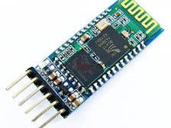HC-05 BLUETOOTH MODULE

|  |  |
| --- | --- |
| **Brand** | HiLetgo |
| **Hardware Interface** | Bluetooth |
| **Operating System** | Android |
| **Color** | 1pc |
| **Data Link Protocol** | Bluetooth |
| **Item Weight** | 3.5 Grams |

# About this item

* The factory setting is slave mode, but you can set this module to master mode so that you might be able to connect to other Bluetooth 2.0 devices.HC-05 Wireless BT Module
* HC-05 Wireless BT Module: with this HC 05 Bluetooth module,You can quickly add the Bluetooth feature to your Arduino project, and then you can use your android phone to control some gadgets, such as: switch, LED.
* Master and Slave 2-IN-1 HC 05 Module:Working Voltage 3.6V to 6V , Default baud rate:9600,Default pin:1234
* Button: Press the button, the module enter the AT mode. AT commands are executed only in AT mode.
* 6 PIN Dopunt Cable : with this Dupont Cable, you can easily connect this HC-05 Bluetooth module to your Arduino Board

ARDUINO UNO :

**Arduino Uno** is a microcontroller board based on the ATmega328P ([datasheet](http://ww1.microchip.com/downloads/en/DeviceDoc/Atmel-7810-Automotive-Microcontrollers-ATmega328P_Datasheet.pdf)). It has 14 digital input/output pins (of which 6 can be used as PWM outputs), 6 analog inputs, a 16 MHz ceramic resonator (CSTCE16M0V53-R0), a USB connection, a power jack, an ICSP header and a reset button. It contains everything needed to support the microcontroller; simply connect it to a computer with a USB cable or power it with a AC-to-DC adapter or battery to get started.. You can tinker with your Uno without worrying too much about doing something wrong, worst case scenario you can replace the chip for a few dollars and start over again.

"Uno" means one in Italian and was chosen to mark the release of Arduino Software (IDE) 1.0. The Uno board and version 1.0 of Arduino Software (IDE) were the reference versions of Arduino, now evolved to newer releases. The Uno board is the first in a series of USB Arduino boards, and the reference model for the Arduino platform; for an extensive list of current, past or outdated boards see the Arduino index of boards.

### Related Boards

If you are interested in boards with similar functionality, at Arduino you can find:

* [**Arduino Uno Rev3 SMD**](https://store.arduino.cc/products/arduino-uno-rev3-smd)
* 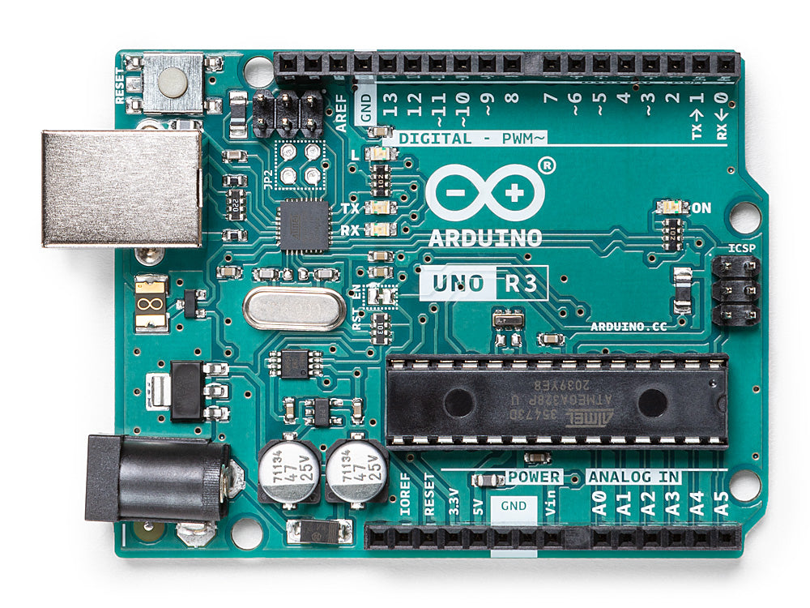[**Arduino Uno WiFi Rev2**](https://store.arduino.cc/products/arduino-uno-wifi-rev2)

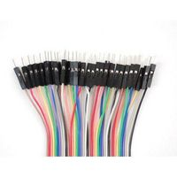Premium Male/Male Jumper Wires, 40 x 3" (75mm):

## Product Information

**Wire Gauge:**

28AWG

**Jacket Color:**

Multi-colored

**Kit Contents:**

40 x 75mm Male / Male Jumper Wires

Premium Male/Male Jumper Wires, 40 x 3" (75mm)

## Product Overview

Male to male jumper wires are useful for making wire harnesses or jumping between headers on circuit boards. These jumper wires come in a 40-pin ribbon cable that can be pulled apart to make individual jumpers or kept together for a organized wiring harness.

* 0.1" sockets on either end and fit cleanly next to each other on standard-pitch 0.1" header
* Each wire is 28AWG (7 strands at 36AWG
* Length: 3"

# MCL053PD

LED, Red, Through Hole, T-1 3/4 (5mm), 10 mA, 2.1 V, 650 nm:

## Product Overview

The MCL053PD is a 5mm HI red round LED Lamp with red diffused lens, through hole mounting, round-shaped lens, 2.8mcd luminous intensity, 650nm peak wavelength, 45° viewing angle and T-1 3/4 bulb size. This LED lamp is made with GaP.

* 45mW Power dissipation
* -40 to +85°C Operating temperature range
* Multicomp Pro products are rated 4.6 out of 5 stars
* 12 month limited warranty *view Terms & Conditions for details
* 96% of customers would recommend to a friend

### Applications

LED Lighting

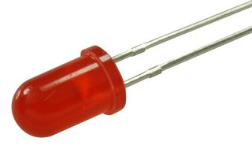

## Product Information

**LED Color:**

Red

**LED Mounting:**

Through Hole

**Bulb Size:**

T-1 3/4 (5mm)

**LED Case Size:**

T-1 3/4 (5mm)

**Forward Current If:**

10mA

**Forward Voltage:**

2.1V

**Wavelength Typ:**

650nm

**Luminous Intensity:**

2.8mcd

**Viewing Angle:**

45°

**Lens Shape:**

Round

# MCL053GT

LED, Green, Through Hole, T-1 3/4 (5mm), 20 mA, 2.1 V, 570 n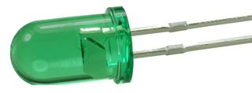m

## Product Overview

The MCL053GT is a 5mm green round LED Lamp with green transparent lens. The green source device is made with GaP.

* 568nm peak wavelength
* 16° Viewing angle
* 45mcd (typical), 20 to 65mcd luminous intensity (IV)
* Multicomp Pro products are rated 4.6 out of 5 stars
* 12 month limited warranty *view Terms & Conditions for details
* 96% of customers would recommend to a friend

### Applications

LED Lighting

# MCL053LYD

LED, Yellow, Through Hole, T-1 3/4 (5mm), 5 mA, 1.9 V, 587 nm

## roduct Overview

* Multicomp Pro products are rated 4.6 out of 5 stars
* 12 month limited warranty *view Terms & Conditions for details
* 96% of customers would recommend to a friend

### Applications

LED Lighting, Consumer Electronics

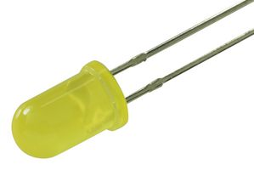

THE MAJOR TRAFFIC LIGHT COLOURS:

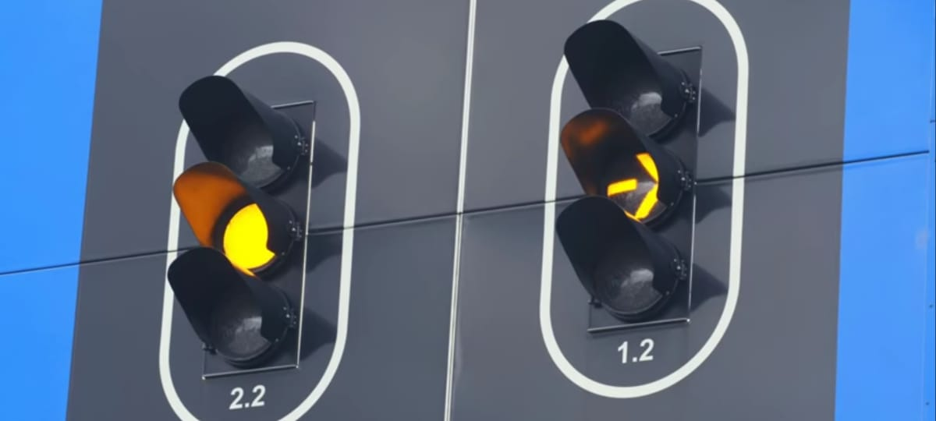 YELLOW LIGHT

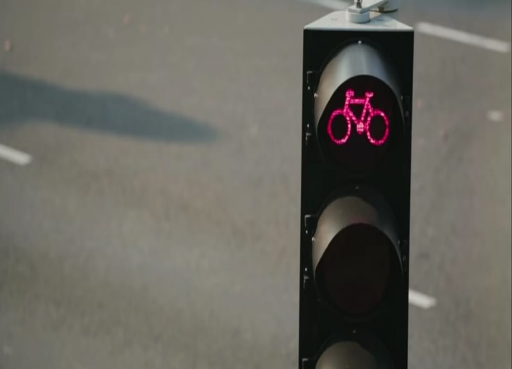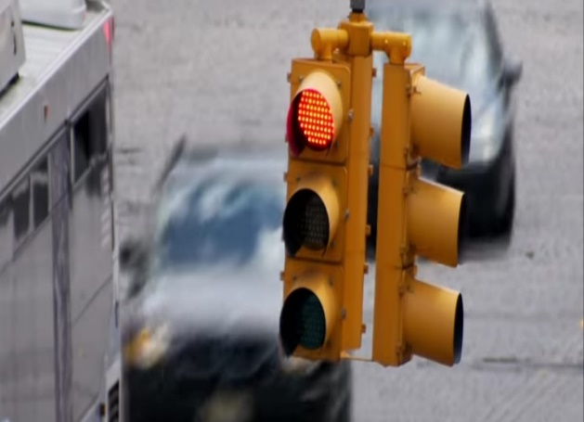ORANGE LIGHT

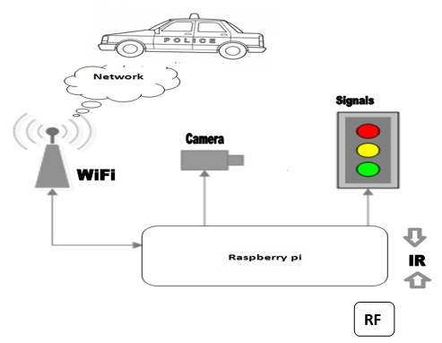 RED LIGHT

HOW THE SENSOR WORK ON THE TRAFFIC CONTROLLING: